Multiple-choice section – choose the correct answer

Question 1 [9.1]

The two triangles shown below are similar.

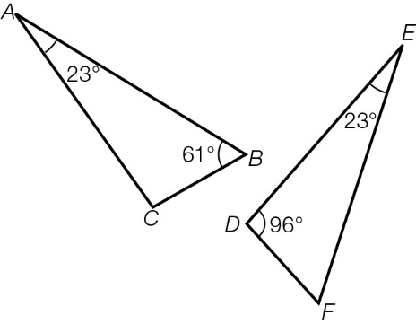

The equivalent side to AB is:

A DE B EF C FD D DF

Question 2 [9.5]

A quadrilateral must be a rhombus if:

A one pair of adjacent sides are equal B one pair of opposite sides are equal

C two pairs of opposite sides are parallel D two pairs of opposite sides are equal

Question 3 [9.6] [10A]

The value of the variable in the diagram shown is:

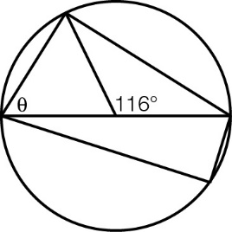

A 45° B 58° C 64° D 90°

Question 4 [12.1]

The graph of would be a:

A circle B rectangular hyperbola C circle D parabola

Question 5 [8.1] [10A]

A possible equation to describe the graph shown is:

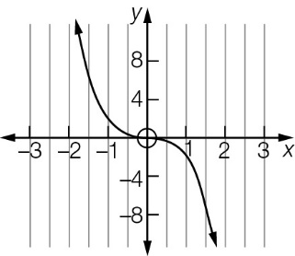

A y = 2x3 B y =  C y = -2x3 D y = 

Question 6 [8.4] [10A]

When 3x3 − 4x2 + 2x − 5 is divided by 2x − 1 the remainder is:

A -14 B  C  D -4

Question 7 [10.1]

A blindfolded person randomly selects a can of soft drink from a pack containing 5 cola, 4 lemonade and 3 orange. The probability that orange is chosen is:

A  B  C  D 

Question 8 [10.5]

A fair coin is tossed three times. The probability that the third toss is heads, if neither of the previous two tosses were heads, is:

A  B  C  D 

Question 9 [11.2] [10A]

In simplest form is written as:

A  B  C  D 

Question 10 [11.3] [10A]

In simplest form  is written as:

A  B  C 20 D 

Question 11 [9.3]

In the diagram below AC bisects both ∠BCD and ∠DAB.

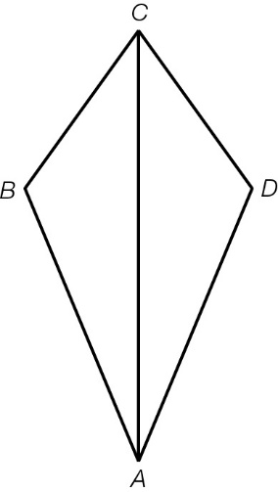

Which of the following tests can be used to prove that ΔABC ≡ ΔADC?

A ASA B SAS C SSS

D There is not enough information to determine if the triangles are congruent.

Question 12 [12.4] [10A]

Simplifying  gives:

A  B  C  D 

Question 13 [13.1]

$5500 invested at 4.75% p.a. compounded annually over 6 years will amount to:

A 5500(1 + 0.475)6 B 5500(1 + 0.04756)

C 5500(1 + 0.0475)6 D 5500(1 + 0.4756)

Question 14 [13.5]

A new car is purchased for $42 000. The value of the car after 2 years, if it depreciates at 18% p.a. of its prime cost, will be:

A $(42 000 − 42 000 × 0.182) B $(42 000 × 0.722)

C $(42 000 − 42 000 × 0.72 × 2) D $(42 000 − 42 000 × 0.18 × 2)

Question 15 [13.3]

A deposit accumulates to $13 550 in 15 months at 8% p.a. compounded quarterly. The initial deposit, in dollars, was closest to:

A $5445 B $9222 C $12 273 D $13 219

Question 16 [10.1]

A reduced pack of playing cards contains only the 13 hearts (Ace to King). A card is selected at random from the pack. The probability that it does not show a prime number is:

A  B  C  D 

Multiple-choice results: \_\_\_ / 16

Short answer section

Question 17 3 marks [9.3]

For the shape below, given CA = CE and ∠BAE = ∠DEA, prove ΔBAE ≡ ΔDEA.

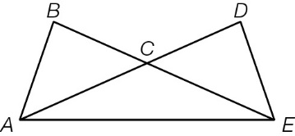

Question 18 6 marks [9.2]

(a) Prove that the two triangles in the diagram are congruent.

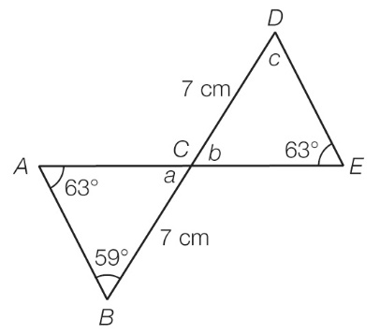

(b) Find the value of the unknown angles.

Question 19 4 marks [9.7] [10A]

(a) AB = BC and ∠AOB = 47°. Find the size of ∠AOC, giving a reason.

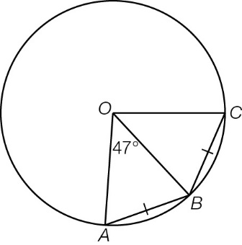

(b) AC = EC = 20 cm, OB = 7 cm. Find the length of OD, giving a reason.

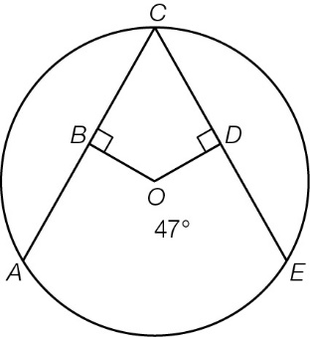

Question 20 8 marks [12.2]

Sketch the graphs of each of the following, showing the key features for each graph.

|  |  |
| --- | --- |
| [10A] (a)  PM10_PR_Sem2A_11ÔÇô14 | (b) (x − 3)2 + (y − 2)2 = 4  PM10_PR_Sem2A_11ÔÇô14 |
| (c) y = 2(x + 1) − 3  PM10_PR_Sem2A_11ÔÇô14 | (d) y = (x − 3)2 + 2  PM10_PR_Sem2A_11ÔÇô14 |

Question 21 3 marks [8.2] [10A]

(a) Sketch the graph of y = x4.



(b) Use your sketch from (a) and transformations to sketch the graph of y = (x − 2)4 + 3 on the same axes.

Question 22 6 marks [8.3] [10A]

Use long division to find the quotient and remainder for:

(a) (x4 + 3x3 + 2x2 − 2x − 4) ÷ (x − 1) (b) (3x3 + 2x − 5) ÷ (x + 3)

Question 23 5 marks [10.2]

In a class of 25 students, 12 students have travelled overseas, 9 have a smartwatch and 7 have neither travelled overseas nor have a smartwatch.

(a) Represent this information in a two-way table.

(b) Use the table to state the number of students who have both travelled overseas and have a smartwatch.

(c) Use the table to find the probability of a student:

(i) having travelled overseas but not having a smartwatch

(ii) having a smartwatch but not having travelled overseas.

Question 24 5 marks [10.4]

A coin is biased such that the probability of getting ‘heads’ on a toss is 0.55. Let H represent ‘result is heads’ and T represent ‘result is tails’.

(a) Draw a probability tree diagram to represent two tosses of this coin.

(b) Find the probability of two tosses giving the following results:

(i) two heads (ii) two tails (iii) at least one heads.

Question 25 3 marks [10.6]

The probability that Anne will kick a goal in the next quarter is 0.85. The probability that Lalita will kick a goal in the next quarter is 0.75. Find the probability that:

(a) they both kick a goal in the next quarter

(b) neither kicks a goal in the next quarter

(c) at least one of them kicks a goal in the next quarter.

Question 26 3 marks [11.4] [10A]

Expand and simplify each of the following.

(a)  (b) 

Question 27 4 marks [11.5] [10A]

Express the following in simplest form with a rational denominator.

**(a)**  **(b)** 

Question 28 6 marks [13.2]

Calculate the total amount owing, correct to the nearest cent, after 5 years on a loan of   
$25 000 if the 7.2% p.a. interest is compounded:

**(a)** annually **(b)** half-yearly **(c)** quarterly

Question 29 2 marks [13.4]

$60 000 is invested at 11.25% p.a. compounding half-yearly. Find the effective rate of interest (r*ef*), rounded to 2 decimal places.

Question 30 2 marks [13.6]

The population of a town is decreasing at a rate of 0.75% per month. Find an estimate for the population at the end of the next 18 months if the current population is 18 950.

Question 31 4 marks [12.6] [10A]

Simplify the following.

**(a)** 3log2(2) + log2 − log2(32) **(b)** 

Short answer results: \_\_\_ / 64

Extended answer section

Question 32 8 marks [12.2]

Find the equation for each of the following graphs.

|  |  |
| --- | --- |
| (a)  PM10_PR_Sem2A_16 | (b)  PM10_PR_Sem2A_17 |
| (c)  PM10_PR_Sem2A_18 | (d)  PM10_PR_Sem2A_19_RR |

Question 33 14 marks [12.2]

(a) (i) Sketch y = (x − 3)(x + 2), marking the x- and y-intercepts.

(ii) Find the coordinates of the turning point.

(b) (i) Sketch y = (x − 3)(x + 2)(x − 1), marking the x- and y-intercepts.

(ii) Use technology to find the coordinates of the turning points.

(c) What can you say about the turning points of a cubic compared to a quadratic graph?

(d) (i) Sketch y = (x − 3)(x + 2)(x − 1)(x + 1), marking the x- and y-intercepts.

(ii) Use technology to find the coordinates of the turning points.

(e) What can you say about the turning points of a quartic compared to a quadratic graph?

Extended answer results: \_\_\_ / 22

TOTAL test results: \_\_\_ / 102